WORK-CASE №2

***Готував матеріал студент Бродзінський Є.В.***

1.Install a type II hypervisor on your home workstation - Virtual Box, VMWare Workstation, Hyper-V (or another one of your choice).

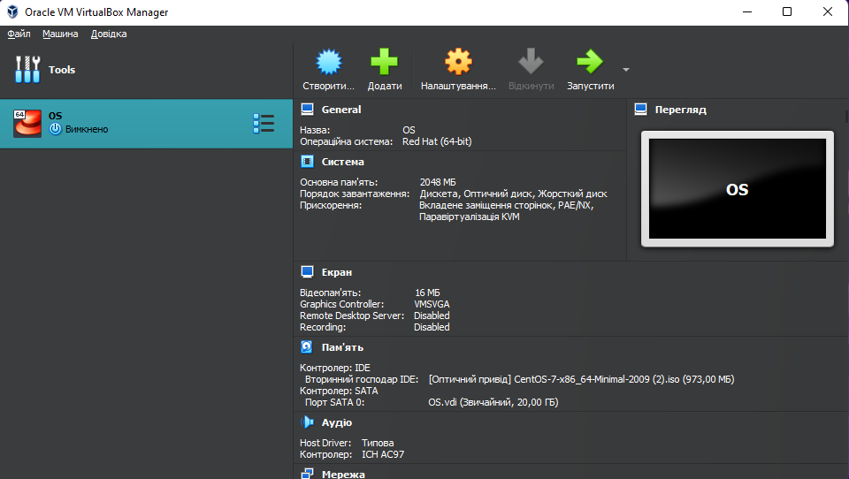I downloaded Virtual Box:

 2.Describe a set of basic actions in the hypervisor you installed:

* Creating a new virtual machine:

1) First, click on the "Machine" button (it is located in the upper left corner), and then click on the "Create" button

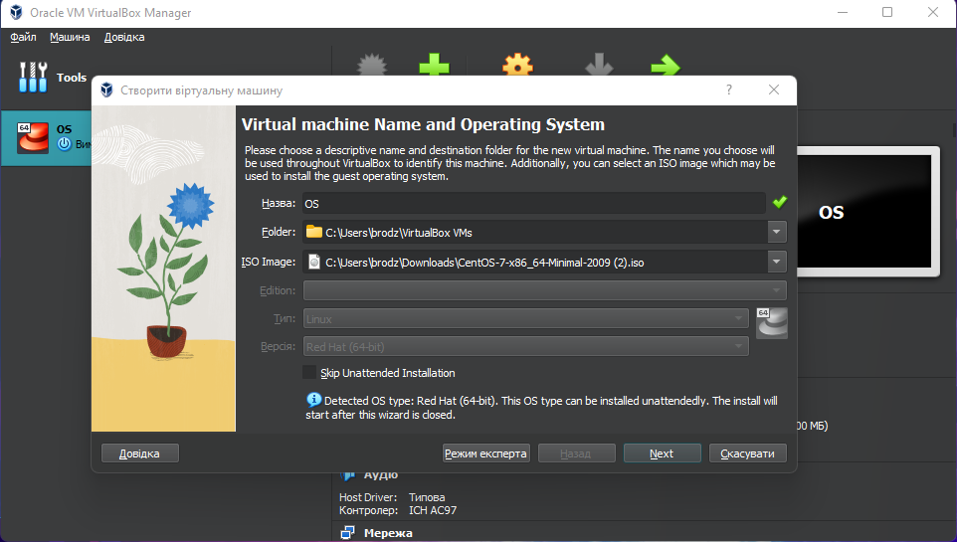

2) In the "Create a machine" menu, you need to give the name of your virtual machine, select the folder where your machine will be placed, select the ISO file or the type and version of the OS that you need to install on the virtual machine, and only then click the "Next" button;

3)The next thing we need to do is select the amount of main memory and processors;

4) In the next menu, you need to set a nickname and password and allocate space on the hard disk for the virtual hard disk, and press the "Next" button;

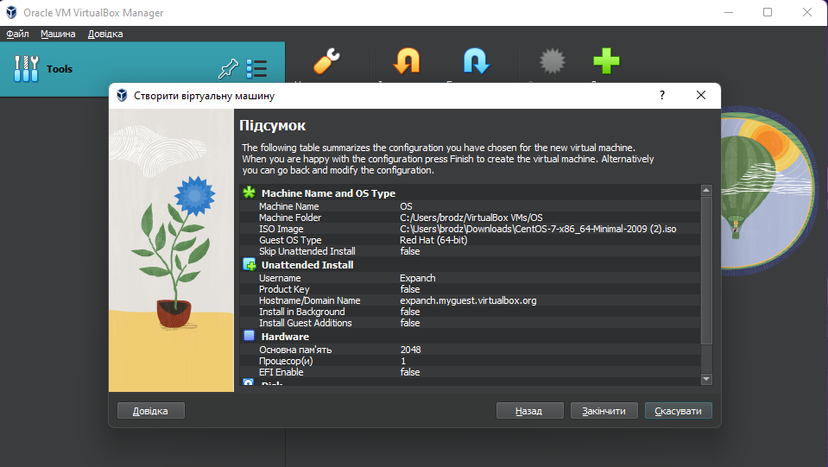5) And already in the next menu you can view the final parameters of the virtual machine, to complete the creation of the machine you need to click the "Finish" button.

* Selecting/adding equipment available for the virtual machine;

1)At the beginning, we need to go into the virtual machine settings ;

2)After opening the settings menu, we need to press the "USB" button, and already in the "USB" menu, we can click on "Add a new USB filter with all fields..." and select the device we need.

* Setting up the network and connecting to Wi-Fi points;

1)At the beginning, we need to go into the virtual machine settings;

2) After opening the settings menu, we need to press the "Network" button, and already in the "Network" menu we can configure Wi-fi and connect to it.

* Ability to work with external media (flash memory).

If we need to connect our flash drive to the virtual machine, we need to click "Settings" of the virtual machine, then click "USB", and after that click "Add new USB filter" and select the flash drive.

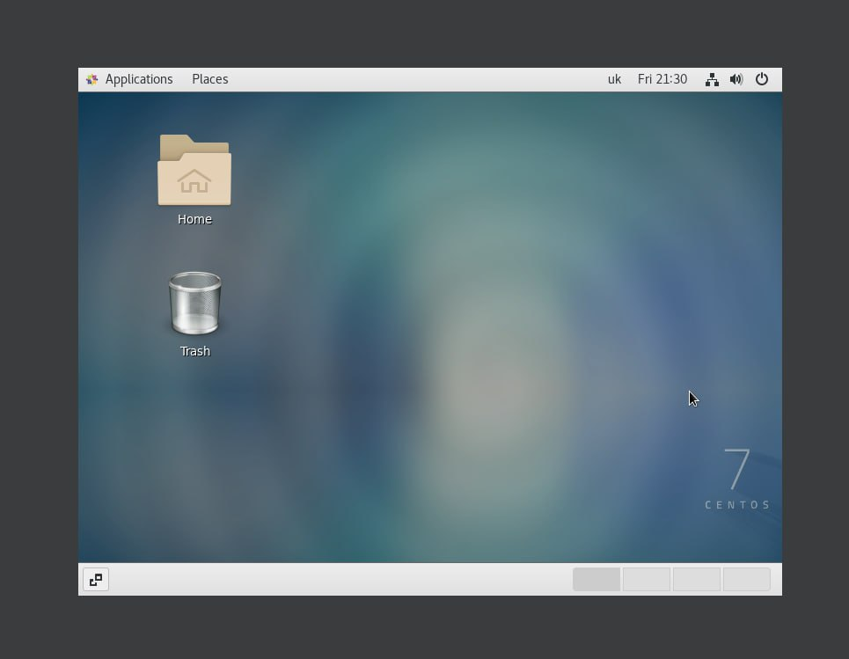3.Install the GNU/Linux CentOS operating system (or another convenient distribution) in your hypervisor in a basic configuration with a graphical shell.

***Готував матеріал студент Кравченко Т.І.***

4.Create another virtual machine and do the following for it:

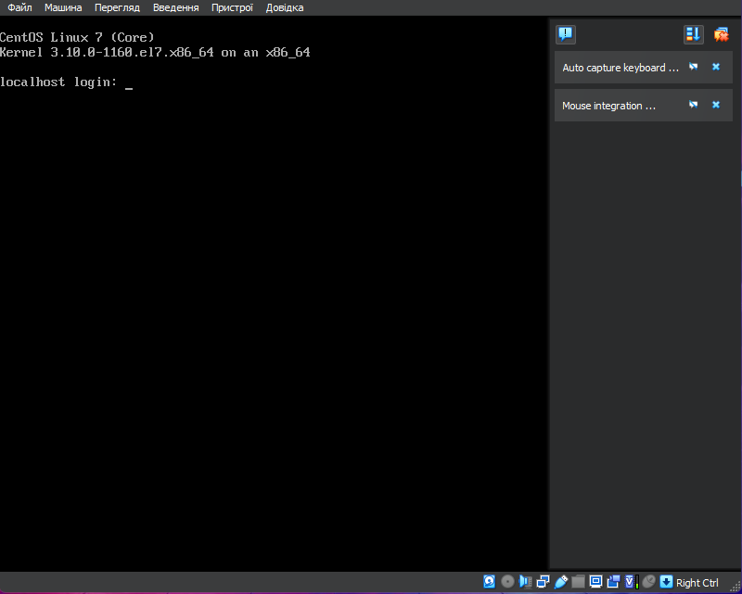Install the GNU/Linux CentOS operating system in a minimal configuration with terminal input-output without a graphical interface;

•Install the GNOME graphical program on top of the OS installed in an external point;